Lasers and Lithotripsy: My Endourology Observership in Sydney
I undertook a short observership at Nepean Hospital in Sydney, Australia, with a focus on endourology, particularly the management of urinary tract stone disease and benign prostatic enlargement. Nepean Hospital is a modern, well-equipped tertiary centre in outer Sydney and offers an excellent clinical and educational setting. I also had the opportunity to attend the adjacent private Nepean Hospital, which provided valuable exposure to urological practice within the Australian private healthcare system and allowed comparison with public sector care.
During the observership, I saw a range of advanced endourological procedures. These included flexible ureterorenoscopy with flexible and navigable ureteric access sheaths, prone endoscopic combined intrarenal surgery (ECIRS) for complex stone disease, as well as Holmium Laser Enucleation of the Prostate (HoLEP) performed using both the three-lobe and en-bloc technique. Observing these procedures enhanced my understanding of operative strategies, patient selection and theatre workflow.
I was fortunate to learn from several experienced consultants during my time at Nepean. In particular, I am grateful to Dr Raymond Ko for his teaching and guidance in the management of stone disease, including operative planning and endoscopic approaches. I also benefited greatly from the teaching of Dr Celi Varol and Dr Nick Mehan, who provided valuable instruction and discussion around HoLEP techniques, including technical nuances of both three-lobe and en-bloc enucleation. These interactions significantly contributed to my learning and professional development.
An additional highlight of the observership was meeting consultants who had previously completed their urology fellowships in the United Kingdom. It was particularly rewarding to be able to share experiences, compare training pathways, and discuss similarities and differences between UK and Australian urological practice. These conversations provided useful perspective and reinforced the value of international collaboration and exchange.
Beyond the clinical experience, the observership also allowed me to gain insight into the structure and delivery of healthcare within the Australian system. I had the opportunity to interact with urology residents and fellows, further broadening my understanding of training, service provision, and work culture in Australia.
Alongside the invaluable professional experience, I had the opportunity to explore Sydney and immerse myself in a wide range of cultural activities. Highlights included the seeing the iconic Sydney Opera House, walking through Barangaroo and Circular Quay, visiting Taronga Zoo, and spending time at Manly Beach. This cultural exposure greatly enriched the clinical experience and contributed to what was an exceptionally rewarding and memorable visit.
In summary, this observership at Nepean Hospital was a highly educational and rewarding experience, providing valuable exposure to advanced endourology, insight into the Australian healthcare system, and opportunities for meaningful professional exchange. It has further strengthened my interest in endourology and will positively inform my future clinical practice.
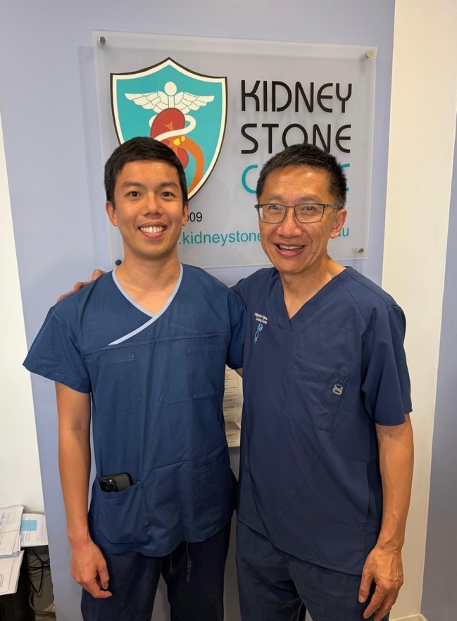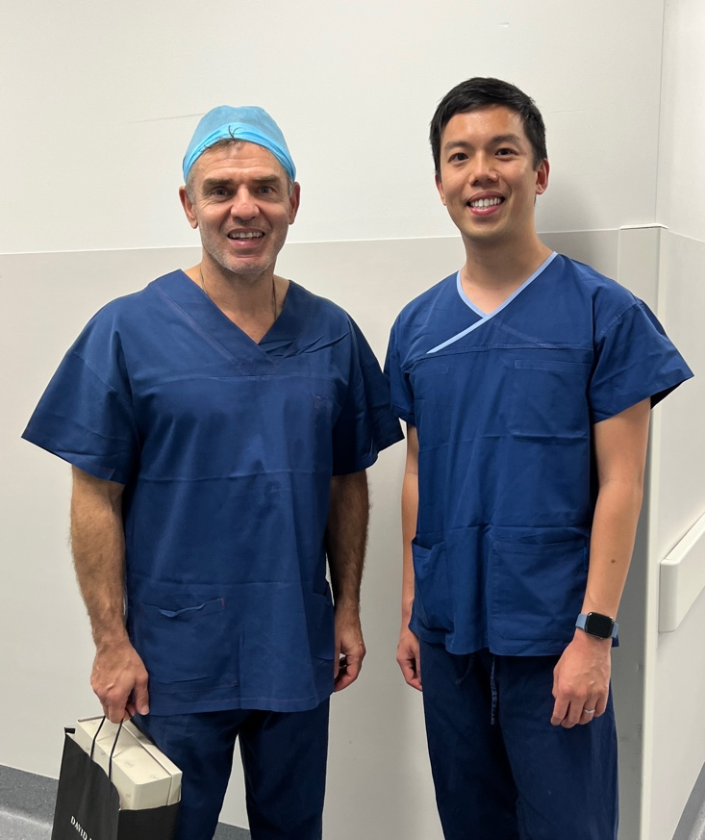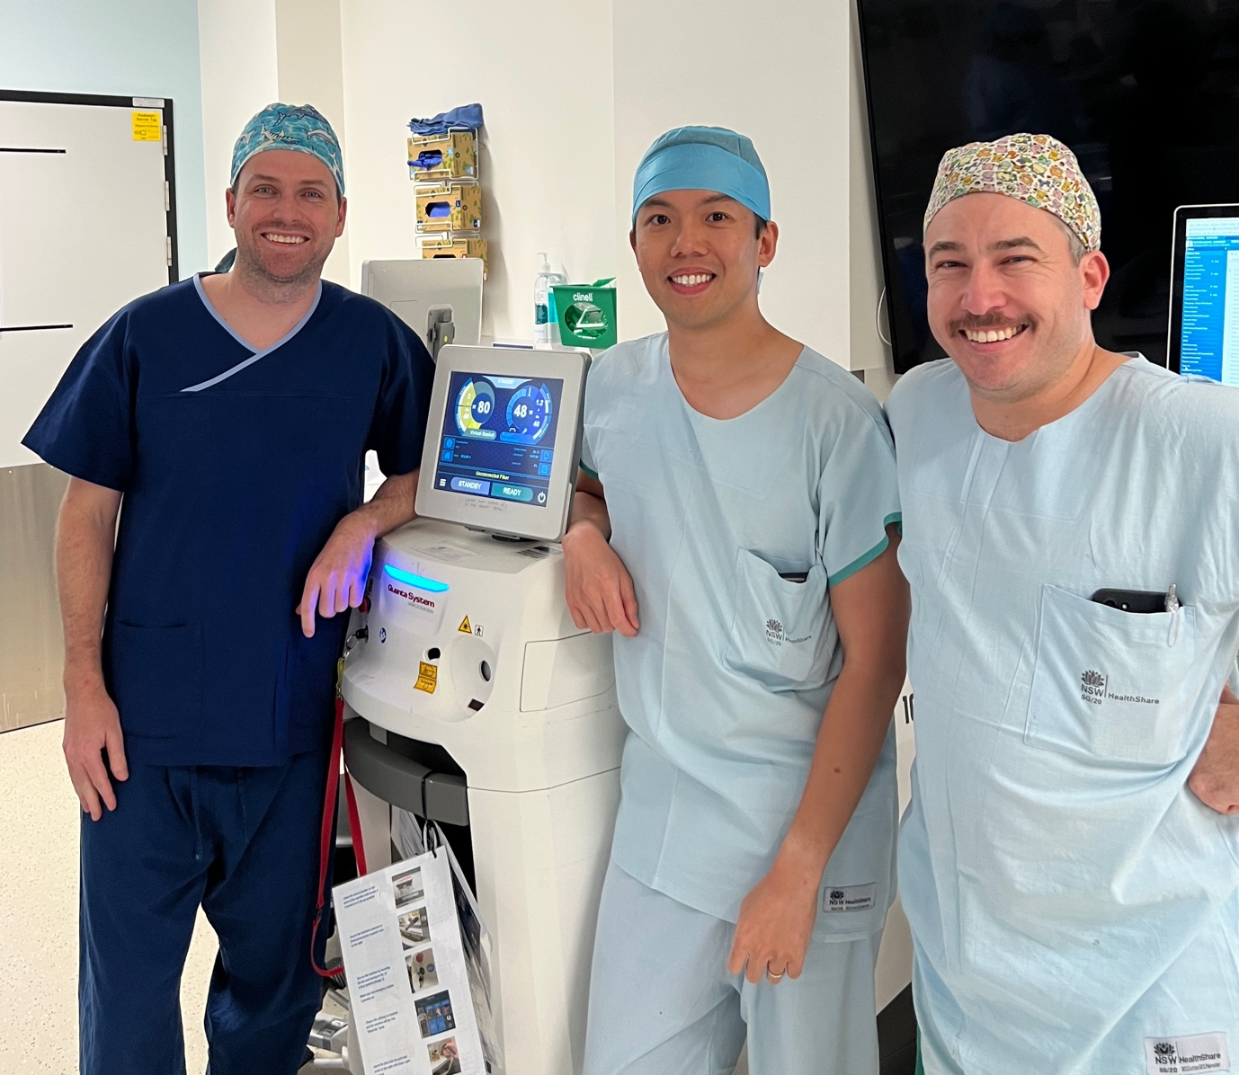
Mr Tony Tien MBBS, BSc, FRCS (Urol)

